



Computer Communications 30 (2007) 2010–2020

www.elsevier.com/locate/comcom

Abstract

Applications of genetic algorithms to optimal multilevel
design of MPLS-based networks

El-Sayed M. El-Alfy *
College of Computer Sciences and Engineering, King Fahd University of Petroleum and Minerals, Dhahran 31261, Saudi Arabia
Received 24 May 2006; received in revised form 4 March 2007; accepted 8 March 2007
Available online 13 March 2007

This paper proposes a design methodology based on the application of genetic algorithms (GA) to ﬁnd a minimal-cost topological
structure of MPLS-based networks. MPLS technology is currently deployed in designing the backbone infrastructure of service provider
networks whereas other parts of the network are still operated using the traditional IP protocol. This makes the overall topological struc-
ture of MPLS-based networks naturally breaks into two prime sub-problems: access network design and backbone network design. The
ultimate goal is to identify the locations of label-edge routers and label-switching routers, and to determine the interconnection links and
their capacities to accommodate expected traﬃc demands. The locations of label edge routers depend on the demands of a given set of
terminal networks which in turn aﬀect the design of the backbone network. This problem is a highly constrained NP-hard optimization
problem for which exact solution approaches do not scale well. We ﬁrst present a multilevel design model that divides the optimal topol-
ogy design into a set of linear programs. Then, we propose GA-based meta-heuristics for solving them. We also discuss the impact of
encoding methods and genetic operators and parameters on the performance. Numerical results for the considered cases show that the
proposed methodology is eﬀective and gives optimal or close to optimal solutions as compared with the exact branch and bound method.
2007 Elsevier B.V. All rights reserved.

Keywords: Genetic algorithms; Network optimization; Multiprotocol-label switching

1. Introduction

Multiprotocol-label switching (MPLS) [1,2] provides a
promising approach for supporting diﬀerentiated quality-
of-service (QoS) required for multimedia delivery over
the Internet. It incorporates a wide-range of capabilities
that combine the merits of both circuit-switched and
packet-switched networks. One of the current applications
of MPLS technology is in the backbone of service provider
networks. Building a cost-eﬀective network that meets its
business and technical goals is a daunting endeavor. This
problem is a highly constrained optimization problem for
which exact solution approaches do not scale well. Over
years, network researchers and practitioners have devel-
oped several models and heuristic algorithms to reduce

* Tel.: +966 3 860 1930; fax: +966 3 860 2174.
E-mail address: alfy@kfupm.edu.sa.

0140-3664/$ - see front matter 2007 Elsevier B.V. All rights reserved.
doi:10.1016/j.comcom.2007.03.005

the computational intricacy of the problem. The goal is
to identify geographical locations of nodes (concentra-
tors/multiplexers, switches, routers, etc.), network connec-
tivity and link capacity to accommodate expected traﬃc
demands with reasonable cost-performance tradeoﬀ.
Unlike other published work on topology design, MPLS
has two distinct sets of nodes: label-edge routers (access
nodes) and label-switching routers (transit nodes) which
complicate the problem further. In this paper, we focus
on hierarchical network design in which the backbone
infrastructure is implemented using MPLS technology
and low level networks utilize the traditional IP protocol.
We also assume that the backbone and the low level net-
works are owned and operated by independent institutions.
Under this assumption, the design of the entire network
can be divided into two independent sub-problems. First,
an access network is designed to accommodate the traﬃc
demands of a given set of terminal networks. Second, a

E-.S.M. El-Alfy / Computer Communications 30 (2007) 2010–2020

2011

service provider builds a cost-eﬀective infrastructure to
connect the selected access nodes. While traﬃc demands
in low level networks are typically centralized, the back-
bone network traﬃc demand is generally distributed and
hence the backbone topology is arbitrarily chosen [3]. After
describing the formal representation of these sub-problems,
we present solution approaches based on genetic algo-
rithms. We also discuss the impact of encoding methods
and genetic operators and parameters on the performance.
The eﬀectiveness of the proposed methodology is evaluated
for a number of examples and the results are benchmarked
to optimal solutions obtained using the exact branch and
bound method. As mentioned in [4], planning hierarchi-
cally is easier than optimizing the network as a whole since
diﬀerent parts of the hierarchy can be treated indepen-
dently by diﬀerent staﬀ members who maintain and modify
the network. In addition, a minimum cost for the entire
network can still be reached by applying the design at dif-
ferent levels iteratively [3].
The rest of this paper is organized as follows. In the next
section, we ﬁrst survey related work on network topology
design. Then, we review some architectural aspects of
MPLS networks in Section 3 and formulate the design
problem in Section 4. The proposed solution based on
genetic algorithms is presented in Section 5. In Section 6,
we provide simulation results and compare the attained
solutions with the exact optimum. Finally, Section 7 con-
cludes the paper and highlights some possible future
research directions.

2. Related work

Network planning and optimal topological design has
been an area of extensive research since the early days of
computer networks [5]. Several studies have been published
on topology design for circuit-switched and packet-
switched networks [6–8]. In general, the network design
problem is formulated as an optimization problem with
the objective of minimizing (or maximizing) a cost function
(or a performance metric) subject to a set of constraints.
Diﬀerent performance metrics can be used such as average
packet delay, average hop count, link utilization, etc. Con-
straints can vary based on geographical constraints, tech-
nology constraints, performance constraints, etc. A
number of mathematical programming techniques such as
linear programming, integer programming and mixed-inte-
ger programming are commonly used for solving it.
Dealing with such problem in today’s large-scale net-
works is a complex endeavor. Since the complexity of this
problem is known to be NP-complete, several heuristic
algorithms based on simulated annealing, evolutionary
strategies and genetic algorithms have been proposed in
the literature to a number of related optimization problems
[9–11]. Although simple genetic algorithms were intro-
duced for unconstrained numerical function optimization,
several approaches have been proposed for extending them
to handle constraints [12]. The terminal assignment prob-

lem, for clustering terminals and connecting them to con-
centrators, is addressed in [13] using heuristic approaches
based on greedy algorithms and genetic algorithms. In
[14], a heuristic approach based on genetic algorithms is
described for solving the topology design of local-area net-
works with the objective of minimizing the average net-
work delay. Designing a campus network topology is
addressed in [15] using an evolutionary algorithm based
on fuzzy simulated evolution with Tabu search. In [16],
an evolutionary algorithm has been applied to telecommu-
nication network dimensioning to ﬁnd values of link capac-
ities. One of the best-known network optimization
problems that is used for designing backbone networks is
minimum-spanning tree (MST) problem. In [17], GAs have
been used for solving a variation of MST called degree-
constrained MST. The study in [18] has demonstrated the
topology design of B-ISDN networks using genetic algo-
rithms. The same problem is again addressed in the com-
munications letter [19] using steady state genetic
algorithms. Unlike the work we consider in this paper,
the authors assumed uncapacitated problem with given
node locations and all nodes are of the same type. A com-
monly used heuristic approach for solving the node loca-
tion problem is known as Add-Heuristic [6]. The
topology design of MPLS core network was considered
in [20] and formulated as a mixed-integer program. Since
this problem is known to be NP-complete for which there
is no algorithm known to run in polynomial time, the
authors proposed a heuristic approach based on branch-
and-bound (BB) algorithm for solving it. In [21], the author
proposed greedy randomized adaptive search procedures
(GRASP) for solving the topological design problem of
MPLS networks. In this study, we investigated another
heuristic approach based on genetic algorithms for solv-
ing it; preliminary results have been partially published in
[22].

3. MPLS network architecture

MPLS is built on former ideas of tag switching and label
switching to expedite packet forwarding and traﬃc engi-
neering in packet-switched networks such as the Internet
[1]. A typical MPLS network architecture is illustrated in
Fig. 1. The MPLS network topology can be divided into
MPLS core and MPLS edge. A router supporting MPLS
at the edge is termed as a Label Edge Router (LER) where
incoming packets are classiﬁed into Forwarding Equiva-
lence Classes (FECs). This classiﬁcation is based on the
network-layer information contained in the packet and
any other control information available at the router such
as balancing supported QoS and network utilization. Pack-
ets in the same FEC are forwarded over the same path and
are treated in the same manner. A path from an ingress
LER router to an egress LER router is termed as Label
Switching Path (LSP) or tunnel. Intermediate routers are
MPLS-capable routers and are called Label Switching
Routers (LSRs).

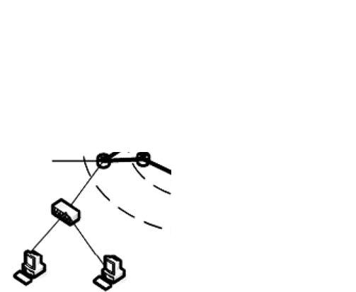
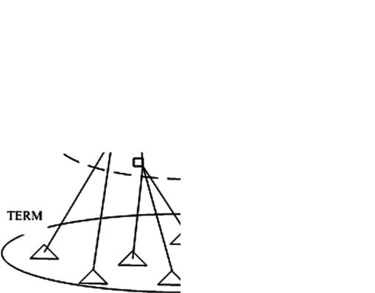
2012

E-.S.M. El-Alfy / Computer Communications 30 (2007) 2010–2020

Fig. 2. MPLS layered topology design.
Fig. 1. A typical MPLS network architecture.

LSR nodes are similar to LER nodes but they are either
not capable of analyzing the network-layer headers at all,
or not capable of doing that at adequate speed. LER nodes
are the connection points between non-MPLS and MPLS-
capable routers hence they are also called access nodes.
LSR nodes are capable of doing label lookup and replace-
ment and are called transit nodes. The label distribution
protocol (LDP) or the resource reservation protocol
(RSVP) can be used to set up and manage tunnels.

4. Methodology and problem formulation

In this section, we describe a hierarchical design meth-
odology and present a mathematical programming formu-
lation for the optimal topology design of MPLS-based
networks. For given expected traﬃc demands, the objective
is to determine the optimal location of nodes, and the inter-
connection links and their capacities to minimize the over-
all costs while satisfying a number of business and technical
constraints. To simplify the design problem, we use a two-
layer approach, as illustrated in Fig. 2, to handle these

objective now is to ﬁnd a best assignment of access net-
works (terminals) to access nodes (LERs) in order to min-
imize the connection costs. Although the associated link
cost can be based on distance, delay, capacity, etc., in the
numerical examples we use Euclidean distance. Let
I = {1, 2, . . . , N} be the set of terminals and
J = {1, 2, . . . , M} be the set of access nodes. We deﬁne
x_{ij}= 1 if terminal i 2 I is connected to access node j 2 J
and x_{ij}= 0 otherwise. The cost of connecting terminal
i 2 I to access node j 2 J is denoted by c_{ij}. A terminal must
be assigned to only one access node and each access node
can handle up to a certain number of terminals as given
by the vector k = (k₁, k₂. . . ,k_{M}). This problem is known
as terminal assignment (TA) problem and is usually
formulated as a combinatorial optimization problem.
Table 1 summarizes the TA formulation as a 0/1 integer
program.
Terminals may have diﬀerent capacity requirements and
in such case the capacity constraints will be modiﬁed as
follows:
X^{N}

interrelated questions separately and combine the solutions
to answer the overall design problem. We start by cluster-
iј1
b_{i}x_{ij}6 k_{j}8j 2 J ;

ing terminals or access networks and assigning them to a
subset of a given set of candidate locations for access nodes
(LERs). Then, we consider the problem of identifying loca-
tions of LSR nodes and determining the interconnection
links and their capacities between LSR nodes and between
LER nodes and LSR nodes.

4.1. Terminal assignment (TA)
where b_{i}is the bandwidth required by terminal i and k_{j}is
the maximum bandwidth of node j. Additional constraints
may be imposed such as type of service available at each
node or link.

Table 1
Integer program formulation for terminal assignment
P_{N}

minF рxЮ ј^{P}M_{j}ј1
subject to
iј1^{c}ij x_{ij}
(1a)

Before looking at the general problem of identifying
access node locations and assigning terminals to them, we
P_{M}
P_{N}
jј1^{x}ij^{ј}1; 8i 2 I
(1b)

ﬁrst address the simpliﬁed assignment problem where
access nodes are given and are assumed to be ﬁxed. The
iј1^{x}ij⁶k_{j}; 8j 2 J
x_{ij}2 {0, 1}, "i 2 I; "j 2 J
(1c)
(1d)

E-.S.M. El-Alfy / Computer Communications 30 (2007) 2010–2020

2013

4.2. Access node location (ANL)

This problem is similar to TA except that the locations
of LER nodes are not known but only a candidate set of
possible locations, J, is given. The goal is to select a subset
of J at which LER nodes are installed and to determine
links connecting terminals to them in order to minimize
the overall installation costs. In addition to link installation
costs, there is a node installation cost for each selected
location. The cost information is given. Again, this prob-
lem can be formulated as a combinatorial optimization
problem as summarized in Table 2. We introduced a new
set of decision variables, y_{j}2 {0, 1}, such that y_{j}= 1 if we
decided to install an LER at location j 2 J; otherwise
y_{j}= 0. Also the objective function is modiﬁed to include
nodal costs as follows:
( )

demands while satisfying a number of speciﬁed constraints
such as maximum link utilization, link capacity, number of
interfaces at each node, diﬀerent levels of service quality in
terms of delay, bandwidth, hop count, etc. The mathemat-
ical formulation of this topology design problem is stated
in Table 3 as a mixed-integer program.
The input data to the optimization procedure consists
of:

• A set of LER nodes I = {1, 2, . . . ,N} described by loca-
tions (x₁, y₁), . . . , (x_{N}, y_{N}).
• A set of demands, D, described by the vector h = (h_{d}:
d 2 D) that speciﬁes the demand volume between each
source–destination pair of LER nodes.
• A set of candidate locations J = {1, 2, . . . ,M} of LSR
nodes described by coordinates (x₁, y₁), . . . , (x_{M}, y_{M}).
• A set of all possible links, E.

min
XM
jј1
g_{j}y_{j}ю
XM X^{N}
jј1 iј1
c_{ij}x_{ij}
;
• Admissible paths for realizing the demand between each
pair of access nodes (deﬁned by link-path indicator
matrix u = (u_{edp}: e 2 E, d 2 D, p 2 P_{d}) of order

where g_{j}is the installation cost for an LER at location
j 2 J.
Similarly, we can assume terminals have diﬀerent band-
width requirements and in such case the capacity con-
straints will be modiﬁed to be,
X^{N}
jEj · jDj Ж jP_{d}j where u_{edp}= 1 if path p for demand d is
passing through link e; otherwise u_{edp}= 0. P_{d}is the set
of paths for realizing demand d for all d 2 D.
• Transit node incidence matrix / = (/_{ev}: "e 2 E, "v 2 J)
of order jEj · jJj where /_{ev}= 1 if link e 2 E is connected
to the transit node v 2 J.

iј1
b_{i}x_{ij}6 k_{j}y_{j}8j 2 J:
• Link capacity/bandwidth vector b = (b_{e}: "e 2 E) repre-
sents upper bound on link capacity if it exists; otherwise
the capacity is zero.

4.3. Transit node location and connectivity (TNLC)

After the locations of LER nodes have been identiﬁed
and connecting access networks to them, it is required to
provide connectivity between LER nodes to accommodate
the expected traﬃc demand. Hence, in this section we
assume that the number and locations of LER nodes are
given. There is a candidate set of possible transit node loca-
tions. The expected traﬃc demand between each pair of
source–destination LER nodes and the admissible paths
are also given. Without loss of generality, we assume
demand is bidirectional. Installing a transit node at a spe-
ciﬁc location incurs a ﬁxed installation cost. Connecting
two nodes has a ﬁxed link installation cost and a varying
cost depending on the link load. Our goal here is to deter-
• Transit node maximum degree k = (k_{v}: "v 2 J).
• Transit node location cost vector g = (g_{v}: "v 2 J) repre-
sents ﬁxed installation costs.
• Link ﬁxed installation fee and capacity-dependent costs:
f = (f_{e}: "e 2 E) and c = (c_{e}: "e 2 E) where c is deﬁned
per capacity unit. The output of the procedure is a min-
imum-cost network deﬁned by a tuple (n, x, x, y) where
• n is a vector of binary values such that n_{v}= 1 if a transit
node is installed at location v 2 J; otherwise, n_{v}= 0.
• x is a vector of binary values such that x_{e}= 1 if link
e 2 E is installed; otherwise, x_{e}= 0.
• x = (x_{dp}: "d 2 D, p 2 P_{d}) is a non-negative real-valued
ﬂow pattern for realizing demands over admissible paths
such that
X

mine (1) the optimal locations of LSR nodes, (2) the inter-
connections between all nodes, (3) ﬂow pattern for
realizing each demand. An optimal solution to this prob-
p
x_{dp}ј h_{d}; x_{dp}2 R; 8d 2 D:

lem is a minimum-cost topology that accommodates

Table 2
Integer program formulation for access node location (ANL)
P_{N}
Table 3
Mixed integer program formulation for transit node location and
connectivity (TNLC)
min F рn; x; x; yЮ ј^{P}v^{g}v^{n}v^{ю}P_{e}Ѕf_{ie}x_{e}ю c_{e}y_{e}(3a)
subject to

minF рx; yЮ ј^{P}M_{j}ј1^{g}j^{y}j^{ю}P_{M}jј1
iј1^{c}ijx_{ij}
(2a)
P
p^{x}dp^{ј}h_{d}; 8d 2 D
(3b)

subject to
P P
(3c)

P_{M}
jј1^{x}ij^{ј}1; 8i 2 I
(2b)
P^{d}
p^{u}edpx_{dp}ј y_{e}; 8e 2 E
(3d)

P_{N}
iј1^{x}ij⁶k_{j}y_{j}; 8j 2 J
x_{ij}2 {0,1}, "i 2 I; "j 2 J
y_{j}2 {0, 1}, "j 2 J
(2c)
(2d)
(2e)
e/ev^{x}e⁶k_{v}n_{v}; 8v 2 J
y_{e}6 b_{e}x_{e}, "e 2 E
x_{e}2 {0,1}, "e 2 E
n_{v}2 {0,1}, "v 2 J
(3e)
(3f)
(3g)

2014

E-.S.M. El-Alfy / Computer Communications 30 (2007) 2010–2020

• y = (y_{e}: "e 2 E, y_{e}2 R) is a non-negative real-valued
vector representing link loads.

5. GA-based solution

This section explores the application of genetic algo-
rithms for solving the optimization problems formulated
in the previous section. Genetic Algorithms are one of
the most powerful and broadly applicable guided stochas-
tic search techniques for global optimization. These proce-
dures are based on the principles and mechanisms of
natural selection and genetic sciences of biological organ-
isms. A genetic algorithm starts oﬀ with a randomly gener-
ated population of individuals (also called chromosomes).
Each individual represents a solution to the optimization
problem and is associated with a ﬁtness value. New solu-
tions are formed by recombining and perturbing existing
solutions in the current population based on their ﬁtness
to survive. The algorithm repeatedly applies selection,
crossover, mutation and replacement operators until a sat-
isfactory solution is found or a maximum number of itera-
tions is reached. Over time, the ﬁttest individuals will have
a better chance of surviving and the least ﬁt individuals will
be eliminated. Unlike other optimization techniques,
genetic algorithms make few assumptions about the prob-
lem domain and thus can be applied to a wide spectrum of
problems.
The link between genetic algorithms and the optimiza-
tion problem lies in the encoding procedure to represent
decision variables (phenotypes) into chromosomes (geno-
types) and computing ﬁtness values. Fitness values are
non-negative values derived from the objective function
values. Constraints can be handled in diﬀerent ways
[12]. A direct approach is to devise a representation
and genetic operators that ensure feasibility. But this is
not always obvious and makes the solution problem
dependent. Alternatively, we can drop infeasible solu-
tions or use a repair function to transform an infeasible
solution into a feasible one. Finally, we can allow infea-
sible solutions to be in the population but penalize them
by adding a penalty term to the objective function. After
termination the ﬁttest chromosome is decoded back into
the corresponding phenotype. In addition to encoding
and ﬁtness evaluation that are problem dependent, the
design of a GA-based solution involves other issues
including selection, crossover, mutation and replacement
strategies.
Selection. Selecting parent chromosomes for mating can
be done in various ways. We use a common approach
called weighted roulette-wheel selection where members
are selected randomly but proportional to their relative ﬁt-
ness values. This gives credit for good members and bal-
ance required exploration of new regions in the solution
space. In the following, we assume a cost minimization
problem. Hence, a good chromosome is one that has low
relative ﬁtness.

Crossover. Two selected parents from the population are
combined to produce two new individuals (oﬀspring) by
partially exchanging their genes. For example, in single-
point crossover, oﬀspring are formed by swapping bits
after the crossover point between the two parents. The
motivation is that two good parents are more likely to pro-
duce better children even than themselves. The crossover is
controlled by the crossover probability, p_{c}, which is typi-
cally in the range [0.7–.95].
Mutation. One or more genes of a chromosome are
changed randomly to allow other solutions to be explored.
This perturbation improves the performance of GA and
prevents a premature convergence to a local minimum.
The mutation rate greatly aﬀects the performance of the
algorithm. Too much mutation badly aﬀects the results.
Typical values for the mutation probability, p_{m}, are in
the range [0.01–0.2].
Replacement. A new population is formed by replac-
ing individuals in the current population with the
newly generated oﬀspring. A single scalar called gener-
ation gap, ggap 2 [0, 1], is used to control the number
of replaced individuals. In one implementation, a new
generation of size equal to the population size entirely
replaces the current population (ggap = 1). This is
known as generational genetic algorithms (GGA). A
variation of this approach is to allow the best individ-
uals to propagate from the current population to the
new population. This is known as GGA with elitism.
If only one or two individuals are replaced at each
iteration, GA is said to be incremental or steady state
(SSGA).
In the following, we show how to encode and evaluate
individuals in the population for each part of the topology
design problem.

5.1. GA-based terminal assignment (GATA)

Encoding method. The ﬁrst step in designing a genetic
algorithm solution is to devise a suitable encoding scheme.
A solution to the TA problem is represented by an integer
vector x = (x₁, x₂,. . . , x_{N}) where x_{i}= j is the jth LER node
to which the ith terminal is assigned. This encoding method
guarantees that each terminal is assigned to only one LER
node. For a solution vector, x, terminals assigned to the jth
LER are determined by the set {i: x_{i}= j}. A feasible solu-
tion is a vector, x, such that the number of terminals
assigned to each LER is not exceeding its capacity (node
degree), i.e., j{i: x_{i}= j}j 6 k_{j}, "j 2 J. This problem can be
solved using binary string representation as well which
can be done in diﬀerent ways. For example, each integer
can be represented using a ﬁxed number of bits equal to
Шlog₂Mш. The chromosome length is thus N Шlog₂Mш. In
such case, many infeasible solutions are generated because
a terminal can be connected to more than one LER which
is not allowed. These infeasible chromosomes need to be
penalized to reduce their chance in participation in the evo-
lution process. In another representation a chromosome

E-.S.M. El-Alfy / Computer Communications 30 (2007) 2010–2020

can be of NM bits. In this case, each M bits should have 5.3. GA-based transit node location and connectivity
only one bit equal to 1 indicating the LER to which the ter- (GATNLC)
minal is connected. But again this binary representation

2015

does not ensure feasibility.
Fitness evaluation. Each chromosome is assigned a ﬁt-
ness value derived from the objective cost function. If x
is a feasible solution, then
XN
f рxЮ ј c_{ix}i
iј1
If infeasible solutions can exist in the population, we
use a penalty function to handicap them. The ﬁtness
value is deﬁned using a modiﬁed objective function as
given by
f~рxЮ ј f рxЮ ю pрxЮ;
where p(x) deﬁnes the penalty value in terms of node over-
loads and/or number of unsatisﬁed constraints. If we deﬁne
the load of node j at solution x to be g_{j}(x) then the node
overload is max(0, g_{j}(x) k_{j}) and the number of unsatisﬁed
constraints is j{j: max(0, g_{j}(x) k_{j}) > 0}j. In our experi-
mental work, we deﬁned p(x) using one of the following
formulas:
As mentioned in Section 4.3, a solution is deﬁned by a
tuple (n, x, x, y). This solution will be represented as a bin-
ary string corresponding to the ﬂow pattern, x,
x ј рx_{d}: d ј 1; . . . ; DЮ; x_{d}ј рx_{dp}: p ј 1; . . . ; P_{d}Ю:
The link load vector y, and the node and link status vectors
(n and x) are implicitly encoded in the ﬂow pattern since
we can compute them from x as follows:

• The link load is obtained by adding all ﬂows passing
through the link, y = x Ж u^{T}, where u^{T}is the transpose
of matrix u,
• If the carried load on the link is not zero, then the link
should exist, i.e., x = (y „ 0),
• If a link is provided then its end nodes are,
n = (x Ж /^{T}„ 0) where /^{T}is the transpose of matrix /.

The ﬁtness value is deﬁned using the objective function
value if only feasible solutions are allowed in the popula-
tion. Otherwise, we use a penalty function in which the
penalty factor increases over generations, t, as follows:
Xm

p₁рxЮ ј djfj : maxр0; g_{j}рxЮ k_{j}Юgj;
XM
p₂рxЮ ј d maxр0;g_{j}рxЮ k_{j}Ю;
jј1
XM
pрxЮ ј рCtЮª

where
(
G_{i}рxЮ ј^{Ѕ}

iј1
G_{i}рxЮ;

max_{р}0; g_{i}рxЮ^{b}for i ј 1; . . . ; q

p₃рxЮ ј d maxр0;g_{j}рxЮ kj Ю jfj : maxр0;g_{j}рxЮ kj^{Юgj};
jј1
jg_{i}рxЮj^{c}
for i ј q ю 1; . . . ; m

" #
m is the number of constraints,q is the number of inequality

p₄рxЮ ј
XM
jј1
maxр0;g_{j}рxЮ kj^{Ю ю}d
jfj : maxр0;g_{j}рxЮ kj^{Юgj}:
constraints,m q is the number of equality constraints,t is
generation count,C, a, b, c are penalty parameters,g_{i}(x) is
the diﬀerence between the left- and right-hand sides of con-

The penalty factor d is set to a large value so that each
infeasible solution becomes worse than the feasible ones.
When all constraints are satisﬁed (i.e., a feasible solution),
the penalty will be zero and the ﬁtness value will be the
same as the objective function value of the corresponding
phenotype.

5.2. GA-based access node location (GANL)

A solution to this problem is represented similarly as
in GATA using integer vector x = (x₁, x₂, . . . , x_{N}). The
decision vector, y, is implicitly encoded. When evaluating
a chromosome, x, we ﬁrst ﬁnd y then if the node load is
zero, it is not installed and its installation cost is not
added to the objective function value. Otherwise its
installation cost is added to the objective function value.
In our experimental work, whenever we allow infeasible
solutions to be in the population, we use penalty func-
tions similar to those used in GATA. After the program
terminates, we determine the vector y from the best
chromosome.
straint i.

6. Numerical examples

In this section, we present a number of numerical exam-
ples to test the eﬀectiveness of the proposed approach. The
proposed solutions were implemented and simulations
were carried out using MATLAB and the genetic algo-
rithms toolbox [23].

6.1. Terminal assignment

We tested the proposed method GATA for assigning
terminals to LER nodes by using 25 terminal networks
and 5 LER nodes with capacities deﬁned by the vector
k = (8, 6, 4, 3, 4). The locations of terminals and LER nodes
are randomly generated on a square layout of size
200 · 200 as depicted in Fig. 3(a). The assignment cost is
taken as the length of the link connecting a terminal to
an LER node (Euclidian cost). An optimal solution is
found using the branch-and-bound (BB) method which is

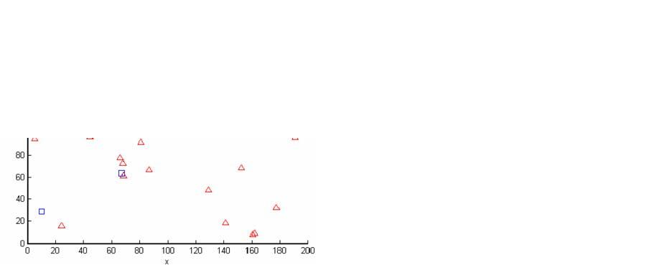
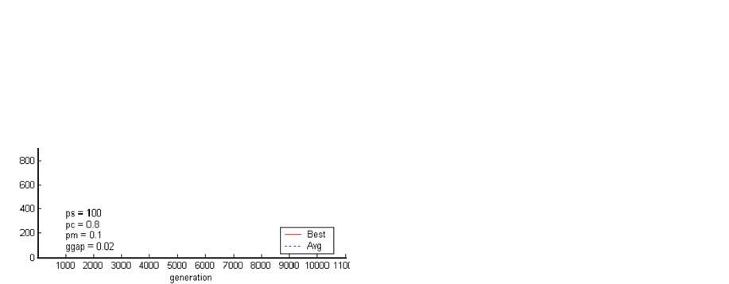
2016

E-.S.M. El-Alfy / Computer Communications 30 (2007) 2010–2020

Fig. 3. (a) Randomly generated terminal and LER locations. (b) An optimal assignment found using BB method.

implemented in MATLAB for solving binary integer pro-
gramming problem as shown in Fig. 3(b) for which the
objective function value is 1436.2373. It is clear that each
terminal is assigned to only one LER and the number of
terminals connected to an LER does not exceed its capacity
(node degree). Then we applied GATA to the same exam-
ple with the following settings: population size p_{s}= 100,
single-point crossover with crossover rate p_{c}= 0.8, muta-
tion rate p_{m}= 0.01, and ﬁtness-based replacement with
generation gap ggap = 0.02. The initial population starts
oﬀ with a set of feasible solutions and during reproduction
infeasible oﬀspring are dropped. The corresponding
changes of the best and average ﬁtness values versus gener-
ations are shown in Fig. 4(a) and the best assignment found
is illustrated in Fig. 4(b). We can see that the algorithm
converges quickly to the best solution for these parameter
settings. After 10,000 generations, the objective function
value of the best solution is 1436.2371 which is exactly
equal to the optimal solution found using the BB methods.
In the following experiments, we allowed infeasible solu-
tions to exist in the initial population and during reproduc-

tion but penalize them. After generating an initial
population uniformly random, we evaluate each chromo-
some and penalize it if it represents an infeasible solution.
Also during reproduction, infeasible oﬀspring are penalized
and inserted in the new generation. As mentioned before
the penalty function makes the ﬁtness value worse and
reduces the likelihood of selecting these chromosomes for
mating. We ﬁrst deﬁned the penalty function as p₄(x)
deﬁned in Section 5.1 with d = 400. The best and average
ﬁtness variations and the best assignments are shown in
Fig. 5 for which the objective function value is
1465.4168. Comparing it with the optimal solution, it is
only 2% higher than the optimum. We can also see that
the convergence becomes slower than if we drop infeasible
solutions. We tried to use other penalty functions such as
p₃(x) with d = 1,000. From the results shown in Fig. 6,
we can that it gives better solution (less than 0.04% higher
than the optimum). We carried out several other experi-
ments with diﬀerent parameter settings and penalty func-
tions [24]. It is found in some implementations of the
GA-based solution that the results are either optimal or

Fig. 4. Using GATA and discard infeasible solutions: (a) The changes of best and average ﬁtness values vs. generations. (b) The best assignment found.

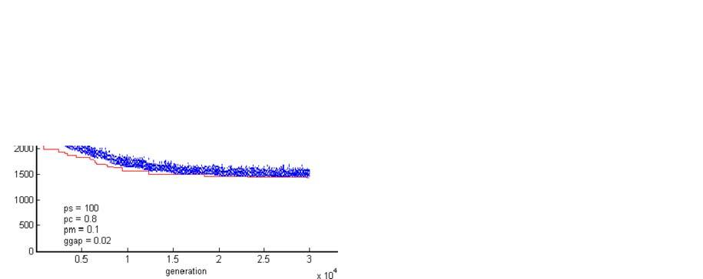
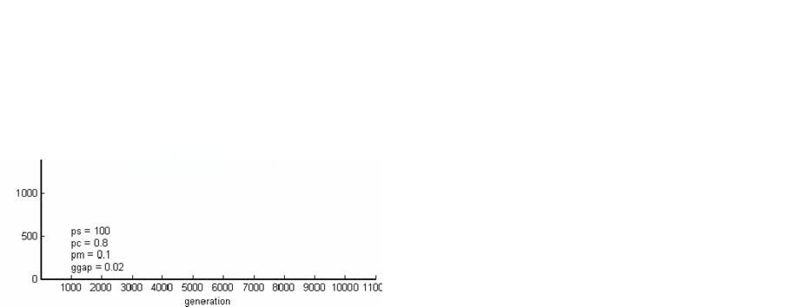
E-.S.M. El-Alfy / Computer Communications 30 (2007) 2010–2020

2017

Fig. 5. Using GATA and a penalty function: (a) The changes of best and average ﬁtness values vs. generations. (b) The best assignment found.

Fig. 6. Using GATA and another penalty function: (a) The changes of best and average ﬁtness values vs. generations. (b) The best assignment found.

very close to optimal. Also a proper selection of the param-
eters can improve the results.

6.2. Access node locations

We carried out a number of experiments to test the
performance of GANL by using a randomly generated
network that has 20 possible access nodes and 100 termi-
nals. The geographical locations of terminals and possible
nodes are randomly generated on a 200 · 200 grid as
shown in Fig. 7(a). The connection costs are computed
as the Euclidian distance between the terminal and access
nodes. The access node installation costs are generated
randomly to be between 50 and 200. Using BB method,
an optimal solution is found to be as shown in
Fig. 7(b) with optimal cost of 4328.1345. Using GANL
with p_{s}= 500, p_{c}= 0.8, p_{m}= 0.02 and ggap = 0.1, the best
solution that satisﬁes the constraints and has minimal cost

is shown in Fig. 8 with cost equal to 4504.045. We can
clearly see that it is only 4% higher than the optimal cost.

6.3. Transit node locations and connectivity

To test our approach for solving TNLC, we considered
a hypothetical backbone network with demand require-
ments as shown in Fig. 9. It is required to identify the loca-
tion of transit nodes, link connectivity, link loads and the
demand realization vector x. This problem is formulated
as a mixed-integer program (MIP) and solved using
LINGO [25]. An optimal solution is found to be as illus-
trated in Fig. 10(a) with objective function value of 682.
Then we carried out the solution using GATNLC with
the following parameter settings: p_{s}= 200, p_{c}= 0.8,
p_{m}= 0.1 and ggap = 0.05. In this experiment, only solu-
tions that satisfy all inequality constraints and approxi-
mately the equality (demand) constraints are allowed to

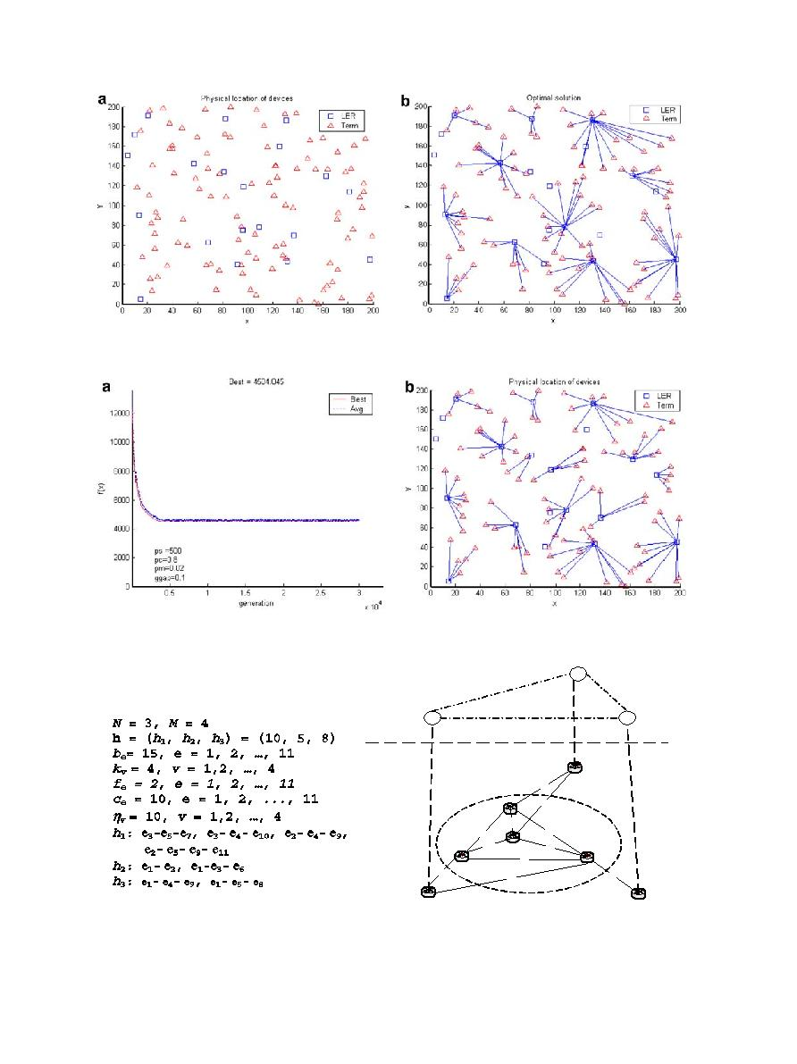
2018

E-.S.M. El-Alfy / Computer Communications 30 (2007) 2010–2020

Fig. 7. ANL problem (a) Randomly generated terminal and possible node locations. (b) An optimal solution using BB method.

Fig. 8. Using GANL: (a) Changes of best and average ﬁtness vs. generations. (b) The best solution found.

3

demand

topology

2
1 0

n₆

5

n₃
8

1

n₂

n₄

n₇

n₅

n₁

Fig. 9. A hypothetical backbone network.

be in the population. Using penalty functions as deﬁned in
Section 5.3 to penalize infeasible solutions, the variations
of the best and average ﬁtness values are shown in

Fig. 10(b) and upon termination the best solution corre-
sponds to an objective function value of 696 which is
2.1% higher than the optimal.

e
5
e
4
e
6
e
7
e
8
e
1
e
3
e
2
e
9
e
1 0
e
1
1

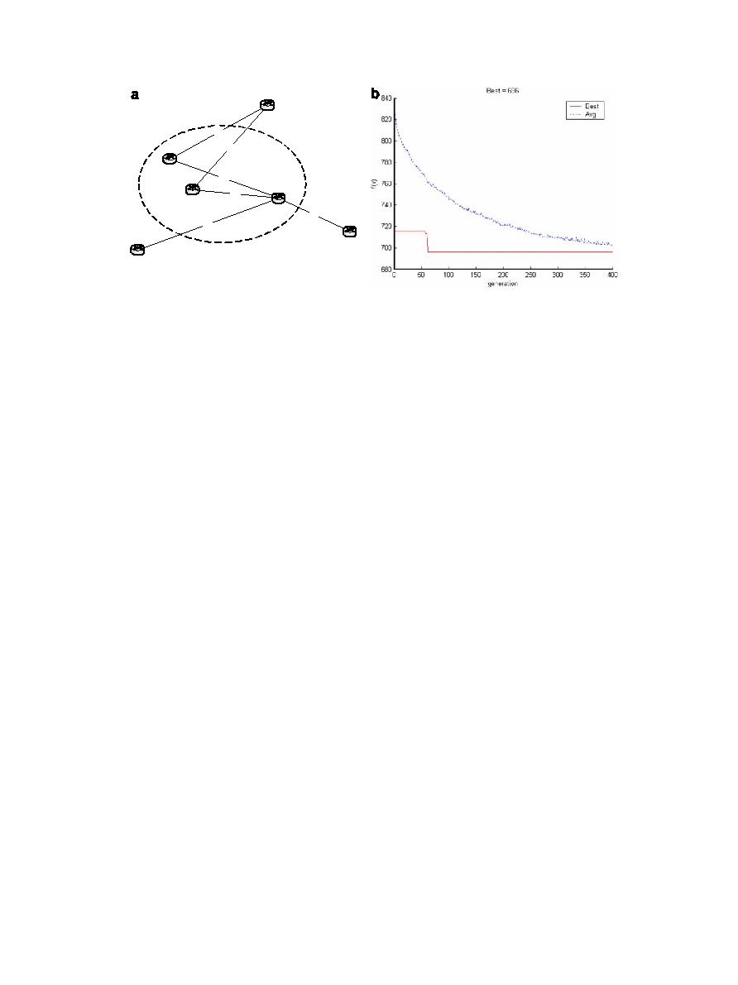

n₂

n6

n₇

E-.S.M. El-Alfy / Computer Communications 30 (2007) 2010–2020

n₃

n₅

n₁

2019

Fig. 10. (a) An optimal solution using LINGO. (b) Changes of best and average ﬁtness vs. generations using GATNLC.

7. Conclusions and future work

In this study, the application of genetic algorithms to the
topological design of MPLS-based networks is demon-
strated. The proposed approach is tested using a number
of hypothetical randomly generated networks. The simula-
tion results show that the proposed method is eﬀective and
can produce optimal or close-to-optimal solutions. The
accuracy of the solution obtained is aﬀected by the GA
parameter settings. Deciding on proper parameter settings
is problem-dependent and is still open for research.
Another important problem that needs to be investigated,
especially when the entire hierarchical network is owned
and operated by one institution, is the uniﬁed model.
Under this model, the consideration of the dependence
between diﬀerent hierarchical levels during the design can
lead to more cost-eﬀective solutions. Finally, a detailed
comparative study of various heuristic approaches for the
design of hierarchical networks is worthwhile.

Acknowledgments

The author thank King Fahd University of Petroleum
and Minerals (KFUPM) for their support during this
work. Also special thanks due to the anonymous reviewers
for their valuable comments that helped in enhancing the
presentation of this manuscript.

References

[1] E. Rosen, A. Viswanathan, R. Callon, Multiprotocol label switching
architecture, RFC 3031, January 2001.
[2] D. Awduche, A. Chiu, A. Elwalid, I. Widjaja, X. Xiao, Overview and
principles of internet traﬃc engineering, RFC 3272, May 2002.
[3] R.R. Boorstyn, H. Frank, Large-scale network topological opti-
mization, IEEE Transactions on Communications 25 (1) (1977)
29–47.
[4] T. Thomadsen, J. Clausen, Hierarchical network design using
simulated annealing, Technical Report, Informatics and Mathemat-
ical Modelling, Technical University of Denmark, 2002.
[5] M. Schwartz, Computer Communication Network Design and
Analysis, Prentice Hall, 1977.

[6] M. Pioro, D. Medhi, Routing, Flow, and Capacity Design in
Communication and Computer Networks, Elsevier Inc., 2004.
[7] S. Srivatsa, P. Seshaiah, On the topological design of a computer
network, Computer Networks and ISDN Systems 27 (4) (1995) 567–
569.
[8] R. Dionne, M. Florian, Exact and approximate algorithms for
optimal network design, Networks 9 (1979) 37–59.
[9] D. Whitley, Genetic Algorithms and Evolutionary Computing, Van
Nostrands Scientiﬁc Encyclopedia, 2002.
[10] M. Srinivas, L.M. Patnaik, Genetic algorithms: a survey, IEEE
Computer 27 (6) (1994) 17–27.
[11] M. Gen, R. Cheng, Genetic Algorithms and Engineering Design,
Wiley, 2000.
[12] Z. Michalewicz, Genetic algorithms, numerical optimization, and
constraints, in: Proc. 6th Int. Conf. Genetic Algorithms, Pittsburgh,
July 15–19, 1995.
[13] S. Khuri, T. Chiu, Heuristic algorithms for the terminal assignment
problem, in: Proc. 1997 ACM/SIGAPP Symp. Applied Computing,
ACM Press, 1997.
[14] R. Elbaum, M. Sidi, Topological design of local-area networks using
genetic algorithms, IEEE/ACM Transactions on Networking 4 (5)
(1996) 766–778.
[15] H. Youssef, S. Sait, S. Khan, An evolutionary algorithm for network
topology design, in: Proc. Int. Joint Conf. Neural Networks, vol. 1,
2001, pp. 744–749.
[16] J. Arabas, S. Kozdrowski, Applying an evolutionary algorithm to
telecommunication network design, IEEE Transactions on Evolu-
tionary Computation 5 (4) (2001) 309–322.
[17] H. Chou, G. Premkumar, C.-H. Chu, Genetic algorithms for
communications network design – an empirical study of the factors
that inﬂuence performance, IEEE Transactions on Evolutionary
Computation 5 (3) (2001) 236–249.
[18] Z. Qin, F. Wu, N. Law, Designing B-ISDN network topologies using
the genetic algorithm, in: Proc. 5th Int. Symp. Modeling, Analysis,
and Simulation on Computer and Telecommunication Systems, 1997,
pp. 140–145.
[19] H. Sayoud, K. Takahashi, B. Vaillant, Designing communication
network topologies using steady-state genetic algorithms, IEEE
Commununication Letters 5 (3) (2001) 113–115.
[20] M. Pioro, A. Myslek, A. Juttner, J. Harmatos, A. Szentesi, Topolog-
ical design of MPLS networks, Globecom, San Antonio, 2001.
[21] A. Myslek, Greedy randomized adaptive search procedures (GRASP)
for topological design of MPLS networks, in: Polish Teletraﬃc
Symposium, Zakopane, 2001.
[22] E. El-Alfy, MPLS network topology design using genetic algorithms,
in: Proc. 4th ACS/IEEE Int. Conf. Computer Systems and Applica-
tions, Dubai/Sharjah, UAE, March 2006.
[23] A. Chipperﬁeld, P. Fleming, H. Pohlheim, C. Fonseca, Genetic
Algorithms Toolbox for MATLAB, User’s Guide.

e
5
e
4
e
8
e
1
e
2
e
9


2020

E-.S.M. El-Alfy / Computer Communications 30 (2007) 2010–2020

[24] E. El-Alfy, Applications of genetic algorithms to MPLS-based
network design, Technical Report, KFUPM-CCSE-2005-005/ICS,
September 2005.
[25] LINGO User’s Guide Manual, LINDO Systems Inc., 2004.

El-Sayed M. El-Alfy received his Ph.D. degree in
Computer Engineering from Stevens Institute of
Technology (SIT), USA in July 2001. He also
holds M.S. in Computer Science from SIT (2001),
as well as M.S. in Automatic Control: Intelligent
Systems (1994) and B.S. (excellent with honor
degree) in Electronics Engineering: Computer
and Control Engineering (1991) from El-
Mansoura University, Egypt. He is currently
working as an Assistant Professor at the Col-
lege of Computer Sciences and Engineering,
King Fahd University of Petroleum and Minerals,

Saudi Arabia since 2004. Before that he joined the Department of
Computer and Control Engineering at Tanta University, Egypt as an
Assistant Professor in 2002. He served as an IT Consultant at the
Canadian Project, El-Mansoura, Egypt (2002-2004). Also, he was with
Lucent Technologies, Inc. as a Member of Technical Staﬀ (MTS) and a
post-doctoral fellow at SIT (2001-2002), an Aﬃliated Instructor at
SIT (1998-2001), a Graduate and Teaching Assistant at the Department of
Computer and Control Engineering, Tanta University, Egypt (1992-1997),
and a Research Assistant at the Department of Computer and Control
Engineering, El-Mansoura University, Egypt (1991-1992). He is a
member of IEEE, IEEE Communications Society CISTC, Arab Computer
Society (ACS), and the Egyptian Body of Engineers. He is serving on
the program committee of IEEE ICC 2007, IEEE CEC 2007, and ICIT
2007 conferences and as a reviewer for several conferences and
some journals. His research interests include network design and
performance optimization; security management; applications of compu-
tational intelligence in network-related problems and decision support
systems.

